Java 15 PROGRAM (ASSIGNMENT)
10 Simple Java Programs (Using Only Operators & Conditions)
1. Add Two Numbers
👉 Covers: Arithmetic operator +
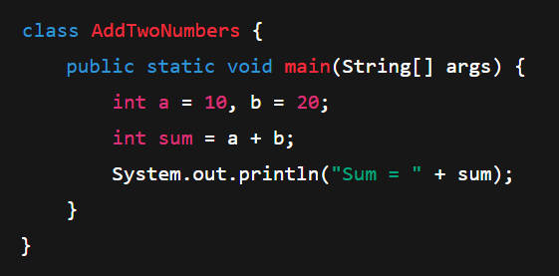

2. Subtract Two Numbers
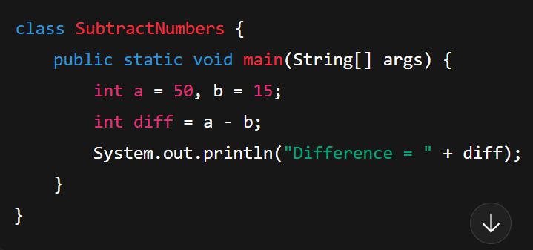

3. Multiply and Divide Two Numbers
(H.W.)
4. Check Even or Odd
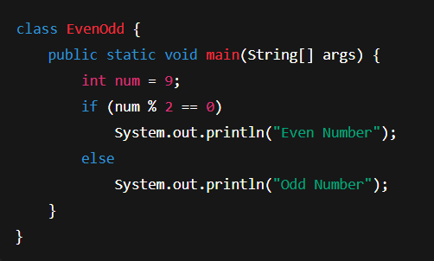

5. Check Positive, Negative or Zero

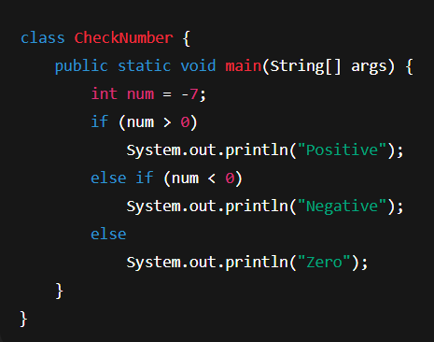

6. Find Greater of Two Numbers
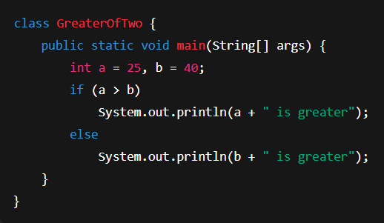

7. Find Greatest of Three Numbers
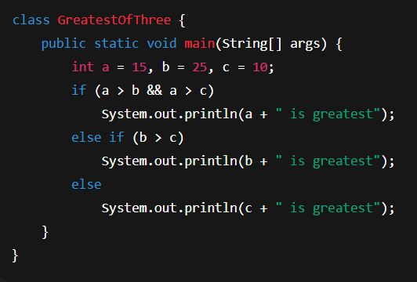

8. Check if Number is Divisible by 5 and 11

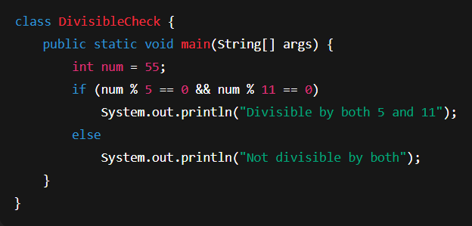
9. Find Maximum Using Ternary Operator
(Ternary operator ek short cut hota hai if-else likhne ka.
Yani — ek hi line me condition check karke decide kar sakte ho ki kya karna hai.)
⚙️ Formula (Syntax):
(condition) ? value_agar_true : value_agar_false;
👉 Agar condition true hai to pehla value lo,
👉 agar false hai to doosra value lo.
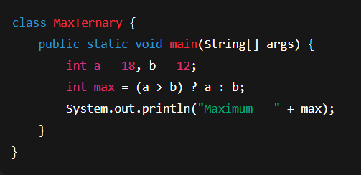
10. Find Greatest of Three Numbers
👉 Nested ternary: Pehle a aur b compare karega, fir usme se jo bada hai uska comparison c se karega.
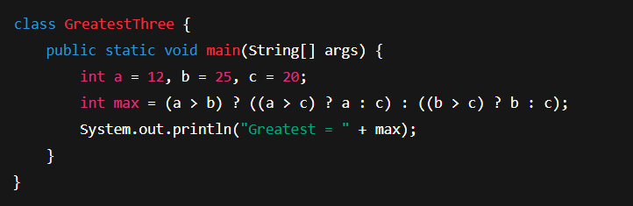
📝 Java Programming Questions
1️⃣ WAP (Write a Program) to find the largest number among three numbers.
2️⃣ WAP to find the largest number among four numbers.
3️⃣ WAP to find the largest number among five numbers.
4️⃣ WAP to find the largest number among six numbers.
5 WAP to find the largest number among seven numbers.

